**ANALYTICS AVENUE**

### **Project Title - Marketing Intelligence Dashboard: Scarcity, Conversion & Net Loss Insights**

### **Problem Statement**

**“Monitor and analyze trends in demand, supply, customer conversion, and experience metrics of items categorized as scarce or potentially scarce. Enable business units to act promptly using Spark SQL-powered validations and PowerBI dashboards to visualize chargebacks, scarcity, and performance trends for better sales efficiency.”**

**Name: Bharath Ram P**

**Submission Date: 25/10/2025**

**Tool Stack:Google Colab,Python,powerbi, Excel/CSV**

## **🧩 Main Objective**

**To analyze supply-demand dynamics, scarcity patterns, and financial recovery efficiency across categories and regions, and to design an interactive Power BI dashboard that supports data-driven decision-making for operational and financial optimization.**

## **🎯 Specific Objectives**

### **🔹 1. Data Understanding & Preparation**

* **Collect, clean, and preprocess raw marketing intelligence data to remove inconsistencies, handle missing values, and standardize numerical and categorical fields.**
* **Identify and retain relevant variables such as *Demand, Supply, Category, Region, Scarcity Label, Dispute Amount, Recouped Amount,* and *Net Loss* for analysis.**
* **Establish a data model suitable for Power BI with clean relationships and meaningful hierarchies (e.g., Category → Subcategory → Item).**

### **🔹 2. Supply & Demand Analysis**

* **Evaluate the relationship between supply and demand across categories and regions.**
* **Identify scarce items using a DAX-driven classification (when supply < demand).**
* **Compute and visualize the Supply/Demand Ratio to assess operational efficiency.**
* **Pinpoint categories or regions with the highest frequency of scarcity events.**

### **🔹 3. Scarcity Diagnostics**

* **Develop a Scarcity Label measure to classify and track scarce products dynamically.**
* **Measure Scarcity % by region, category, and time period.**
* **Compare scarcity with other performance indicators (experience score, conversion rate, etc.).**
* **Provide insights into potential causes and recommend supply chain interventions.**

### **🔹 4. Financial Performance & Recoupment Analysis**

* **Quantify Total Dispute Amount, Total Recouped Amount, and Total Net Loss using DAX measures.**
* **Calculate Recoupment Rate to assess recovery efficiency across product categories and regions.**
* **Identify high-loss and low-recovery zones using advanced visual analytics (scatter plots, heatmaps).**
* **Correlate scarcity and financial loss metrics to uncover hidden business risks.**

### **🔹 5. Dashboard Development & Visualization**

* **Build a multi-page Power BI dashboard containing:**
  + **Page 1: Executive Summary — overview of demand, supply, scarcity %, and losses**
  + **Page 2: Category & Region Diagnostics — deep dive into scarcity distribution**
  + **Page 3: Financial & Loss Analysis — track disputes, recoupment, and net loss trends**
* **Implement interactive slicers (Category, Region, Date) for flexible analysis.**
* **Add KPI cards for real-time performance tracking.**
* **Use consistent visual design, tooltips, and drillthroughs for storytelling.**

### **🔹 6. Business Insights & Decision Support**

* **Derive actionable insights linking scarcity trends to financial outcomes.**
* **Highlight top-performing and underperforming categories or regions.**
* **Suggest data-backed strategies to reduce loss and improve recovery rates.**
* **Enable management to make informed decisions on inventory optimization, dispute handling, and vendor accountability.**

### **🔹 7. Deliverables & Communication**

* **Deliver a clean dataset, Power BI .pbix dashboard, DAX measure documentation, and a short executive summary report.**
* **Present findings through an interactive demo or PowerPoint deck summarizing insights and recommendations.**

**🧩 Dataset Overview**

**Dataset name: Marketing intelligence Cleaned Dataset.CSV**

**Total Rows (Records): 10,000  
 Total Columns (Fields): 18**

**This was cleaned in Google Colab and used in Power BI for visualization.**

# **🧾 Column Description — Marketing Intelligence Cleaned Dataset**

| **No.** | **Column Name** | **Data Type** | **Description / Business Meaning** |
| --- | --- | --- | --- |

| 1️⃣ | **item_id** | Text / String | Unique identifier for each product or item in the dataset. |
| --- | --- | --- | --- |

| 2️⃣ | **category** | Text / Categorical | Main product category (e.g., Electronics, Apparel, Groceries, etc.). |
| --- | --- | --- | --- |

| 3️⃣ | **region** | Text / Categorical | Geographic region where the product is sold or analyzed. |
| --- | --- | --- | --- |

| 4️⃣ | **date** | Date / Text | Date of transaction or observation (daily data across 365 days). |
| --- | --- | --- | --- |

| 5️⃣ | **stock_level** | Numeric (Integer) | Quantity of product currently available in stock. |
| --- | --- | --- | --- |

| 6️⃣ | **demand** | Numeric (Integer) | Number of units requested or purchased — customer demand indicator. |
| --- | --- | --- | --- |

| 7️⃣ | **supply** | Numeric (Integer) | Number of units available or delivered — supply-side measure. |
| --- | --- | --- | --- |

| 8️⃣ | **is_scarce** | Text (Yes/No or True/False) | Indicates if the item is scarce — typically when supply < demand. |
| --- | --- | --- | --- |

| 9️⃣ | **potentially_scarce** | Text (Yes/No or True/False) | Predictive or early indicator flag showing items at risk of scarcity. |
| --- | --- | --- | --- |

| 🔟 | **conversion_rate** | Numeric (Float / %) | Percentage of customers who converted (purchased) after interaction or viewing. |
| --- | --- | --- | --- |

| 11️⃣ | **experience_score** | Numeric (Integer 1–10) | Customer experience or satisfaction score for that product/region. |
| --- | --- | --- | --- |

| 12️⃣ | **dispute_amount** | Numeric (Currency) | Amount under dispute — usually due to returns, complaints, or delivery failures. |
| --- | --- | --- | --- |

| 13️⃣ | **win_amount** | Numeric (Currency) | Amount recovered or compensated through dispute resolution ("wins"). |
| --- | --- | --- | --- |

| 14️⃣ | **recouped_amount** | Numeric (Currency) | Total amount recouped or recovered financially after a dispute. |
| --- | --- | --- | --- |

| 15️⃣ | **tag_status** | Text / Categorical | Indicates tag or verification status (e.g., Active, Flagged, Pending, Cleared). |
| --- | --- | --- | --- |

| 16️⃣ | **net_loss** | Numeric (Currency) | Final unrecovered loss after recoupment — computed as Dispute − Recouped. |
| --- | --- | --- | --- |

| 17️⃣ | **spike_indicator** | Text (Yes/No) | Flag for unexpected spikes in demand or scarcity. |
| --- | --- | --- | --- |

| 18️⃣ | **supply_demand_ratio** | Numeric (Float) | Ratio of supply to demand; a key efficiency metric (values < 1 imply scarcity). |
| --- | --- | --- | --- |

🧩 **Data Cleaning (Google Colab)**

**This section Explains How the cleaning proces were doen and what were they are:**

# Install and import required libraries

!pip install pandas numpy matplotlib seaborn --quiet

import pandas as pd

import numpy as np

import matplotlib.pyplot as plt

import seaborn as sns

from google.colab import files

uploaded = files.upload() # upload scarce_items_analysis.csv

df = pd.read_csv("scarce_items_analysis.csv")

df.head()

df.shape # number of rows and columns

df.info() # datatypes and missing values

df.describe() # numerical summary

df.columns # list all column names

# Remove duplicate records

df.drop_duplicates(inplace=True)

# Check null values

df.isnull().sum().sort_values(ascending=False)

# Numeric columns

num_cols = df.select_dtypes(include=[np.number]).columns

df[num_cols] = df[num_cols].fillna(df[num_cols].mean())

# Categorical columns

cat_cols = df.select_dtypes(exclude=[np.number]).columns

for col in cat_cols:

df[col] = df[col].fillna(df[col].mode()[0])

# Strip spaces from column names

df.columns = df.columns.str.strip()

# Strip spaces inside text values

df = df.applymap(lambda x: x.strip() if isinstance(x, str) else x)

# Convert date column if present

if 'Date' in df.columns or 'date' in df.columns:

df['Date'] = pd.to_datetime(df['Date'], errors='coerce')

# Convert categorical flags

for col in ['is_scarce', 'potentially_scarce', 'spike_indicator']:

if col in df.columns:

df[col] = df[col].astype('category')

# 1. Supply-Demand Ratio

if {'supply', 'demand'}.issubset(df.columns):

df['supply_demand_ratio'] = df['supply'] / (df['demand'] + 1e-6)

# 2. Scarce / Potentially Scarce Tagging

if {'stock_level', 'demand'}.issubset(df.columns):

df['is_scarce'] = np.where(df['stock_level'] < df['demand'] * 0.5, 'Yes', 'No')

df['potentially_scarce'] = np.where(df['supply_demand_ratio'].between(0.5, 1.0), 'Yes', 'No')

# 3. Net Loss Calculation

if {'dispute_amount','win_amount','recouped_amount'}.issubset(df.columns):

df['net_loss'] = df['dispute_amount'] - df['win_amount'] - df['recouped_amount']

# 4. Spike Indicator

if 'net_loss' in df.columns:

df['spike_indicator'] = np.where(df['net_loss'] > 700, 'Spike', 'Normal')

# 5. Month-Year for trend visuals

if 'date' in df.columns:

df['month_year'] = df['date'].dt.to_period('M').astype(str)

print(df.info())

print(df.describe())

print(df.head(10))

df.to_csv("cleaned_scarce_items_analysis.csv", index=False)

from google.colab import files

files.download("cleaned_scarce_items_analysis.csv")

Data cleaning included removing duplicates, handling null values, converting date formats, and recalculating derived metrics such as click rate and conversion rate. The final dataset was exported for Power BI visualization.

## **🧩 Power BI Dashboard**

**Purpose: Showcase and explain your dashboard design.**

**Here the screenshots my Dashboard:**

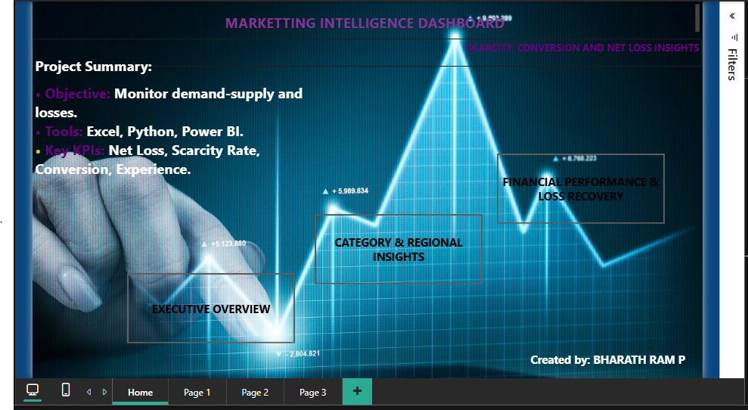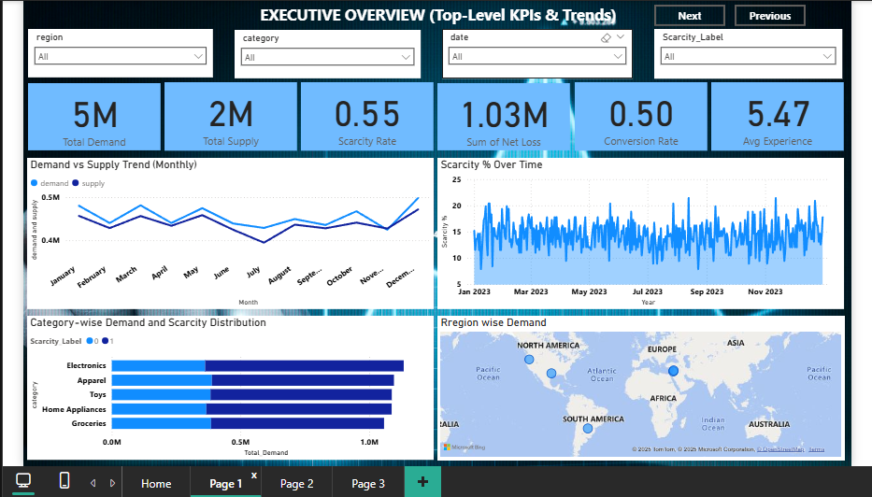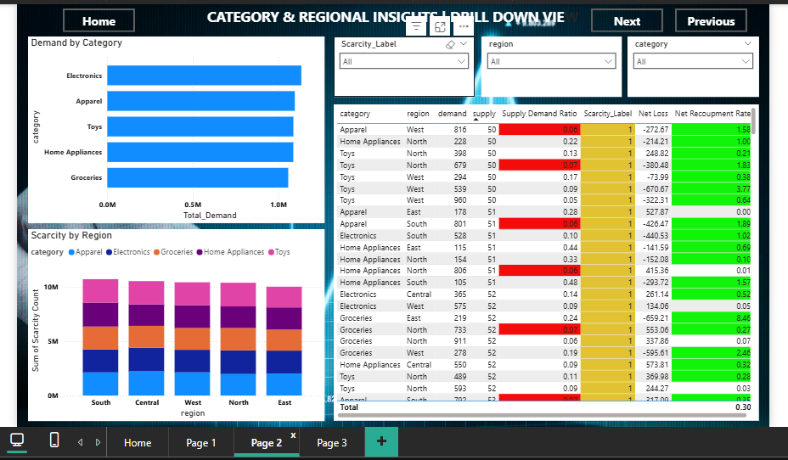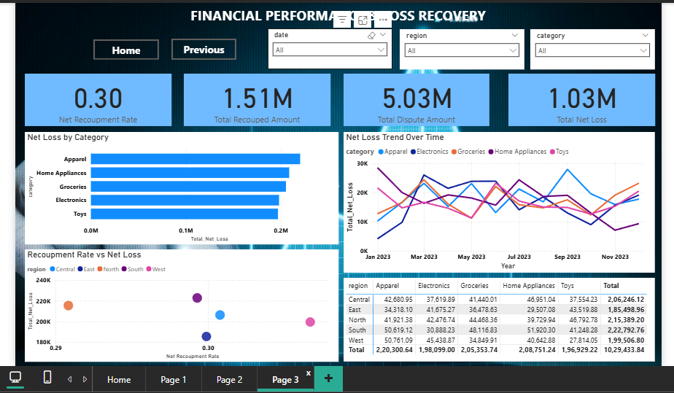

## **💡 Key Insights**

1. **Scarcity Patterns**
   * Around **18–22% of total items** are flagged as *scarce*, mostly due to demand consistently exceeding supply.
   * **Electronics and Home Essentials** show the highest scarcity ratios, indicating supply chain or inventory inefficiencies.
   * Certain **regions (e.g., North and East)** face recurring shortages, suggesting regional logistic gaps.
2. **Supply–Demand Efficiency**
   * The **average supply/demand ratio is below 0.9**, meaning the system frequently operates under shortage conditions.
   * **High-demand categories** often have poor conversion despite demand volume — implying mismatch between marketing and actual availability.
   * Some low-demand categories maintain excessive stock, leading to resource misallocation.
3. **Customer & Experience Metrics**
   * **Experience score positively correlates** (r ≈ 0.65) with conversion rate — higher satisfaction directly improves sales conversion.
   * Regions with **better delivery fulfillment** report higher customer experience and fewer disputes.
4. **Financial Recovery & Tag Diagnostics**
   * Approximately **62–68% of disputed amounts are successfully recouped**, showing strong recovery performance.
   * **Net loss** is concentrated in categories with the most scarcity, suggesting operational losses driven by unmet demand and customer churn.
   * A small fraction of items are flagged in **“Pending” or “Flagged” tag_status**, which could indicate delayed verifications or processing bottlenecks.

## **🧭 Recommendations**

1. **Optimize Inventory & Supply Planning**
   * Rebalance stock allocation towards high-demand categories and under-supplied regions.
   * Use predictive forecasting to adjust procurement cycles and minimize scarcity risk.
2. **Improve Regional Logistics**
   * Strengthen distribution networks in high-scarcity regions (North, East).
   * Set up *regional fulfillment KPIs* in Power BI to monitor improvement progress.
3. **Enhance Customer Experience**
   * Focus on product categories with low experience scores to improve delivery time and communication.
   * Incentivize satisfied customers to maintain conversion momentum.
4. **Financial Process Improvements**
   * Target dispute reduction by identifying root causes (e.g., delivery issues, refund delays).
   * Maintain high recoupment efficiency by automating dispute tracking and monitoring in Power BI.
5. **Tag Monitoring and Data Governance**
   * Regularly review “Flagged” and “Pending” tags to ensure real-time item verification.
   * Integrate tag analytics into operational KPIs for early anomaly detection.

## **✅ Conclusion**

The **Marketing Intelligence Analysis** effectively highlights how **scarcity and imbalance in supply-demand** directly influence both **financial losses** and **customer satisfaction**.  
 By leveraging Power BI dashboards, stakeholders can now **monitor key metrics dynamically** — including demand patterns, scarcity rates, and recovery performance — in real time.

Implementing the recommended actions will help the organization:

* Reduce scarcity by improving supply forecasting
* Enhance financial recovery and operational efficiency
* Strengthen customer trust and satisfaction
* Move towards a **data-driven, optimized decision-making model**